Game Design Document

Fill up the Following document

1. Write the title of your project.

Save The Earth

1. What is the goal of the game?

My game is an endless game in which we need to destroy asteroids to increase our score by 1 per asteroid to save our planet Earth.

1. Write a brief story of your game?

It is the END OF THE WORLD!!!!!! Many huge asteroids are coming towards the Earth and we need to protect our EARTH! An advance spaceship with laser beams has been prepared to protect our Earth. We need to shoot the Asteroids with the laser beams to destroy them, so, we can protect our Earth.

1. Which are the playing characters of this game?

* Playing characters are the ones which respond to the user based on the input from the user
* Cars, monkeys, dinos, wizards etc, are the playing characters in the game.

|  |  |  |
| --- | --- | --- |
| Number | Character Name | What can this character do? |
| 1 | Humans | Protect the Earth by  Their SpaceShip |
| 2 |  |  |
| 3 |  |  |
| 4 |  |  |
| 5 |  |  |
| 6 |  |  |
| 7 |  |  |
| 8 |  |  |

1. Which are the Non Playing Characters of this game?

* Non Playing characters are the ones which don't have an action or a behaviour when the user interacts with the game.
* Hurdles, stones, bananas, coins, etc are non playing characters in the game.

|  |  |  |
| --- | --- | --- |
| Number | Character Name | What can this character do? |
| 1 | Earth | Revolve around the sun for our survival |
| 2 | Asteroids | They are coming to destroy the earth |
| 3 | Spaceship | It will shoot laser beams to destroy the asteroids to protect Earth |
| 4 |  |  |
| 5 |  |  |
| 6 |  |  |
| 7 |  |  |
| 8 |  |  |

Draw your imagination of this game. What does this game look like?

* Draw the game either on your computer or on paper,
* Add images of scenes of the game to show each of the playing and non-playing characters at least once.

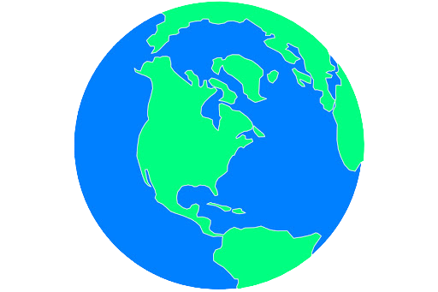

How do you plan to make your game engaging?

My game will have an attractive design making it engaging

If not Engaging then

Scroll down

I will call NOBITA,NINJA HATORI AND JHETHALAL TO MY WORLD